INFO2310 – Capstone Help Systems and tutorials

Table of Contents

1. Introduction
2. Getting Started
3. System requirements
4. Getting help
5. Features
6. Navigation
7. Seeing the catalogue
8. Going into the book details
9. Registering an account
10. Creating new account
11. How to log in
12. Your books
13. Adding your book
14. Editing your book
15. Deleting your book
16. Book requests
17. Requesting a book
18. Receiving a request
19. Your requests.
20. Reviews
21. Conclusion

**Introduction**

This is the Better Books project help system and tutorial. This document is to be used as a guide to learn how to operate our system and learn the features that have been implemented in the project.

**Getting started**

To be able to run this application you will need a computer with a working internet connection. Our project is currently being hosted by Microsoft Azure and can be found at the following URL address to access it: <https://betterbooks20210320133241.azurewebsites.net/>

**Getting help**

For any support related question please email [adhillon2005@conestogac.on.ca](mailto:adhillon2005@conestogac.on.ca)

**Features**

1. Navigation
2. This is the better books application, once you enter the website it loads you right into the catalogue page where you can view the current selection of books. You can view details about each title by selecting the title of the book you wish to view. Users are able to the catalogue by title, author, or the date added for each book. Users are also able to use the search function to search for any specific title they may be looking for.

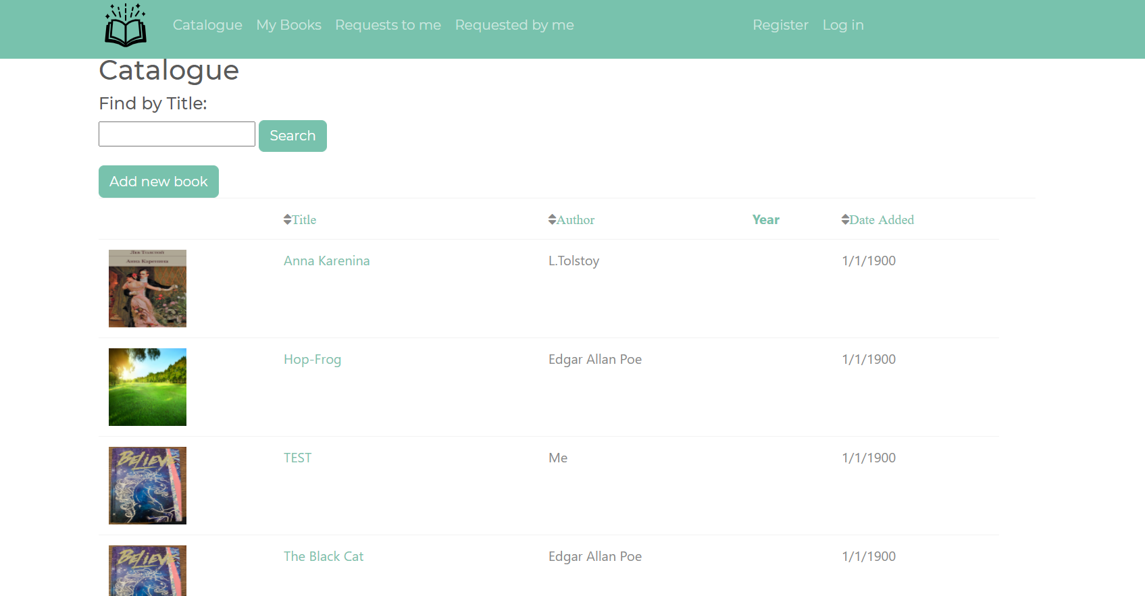

1. Once a book is selected, the application brings you to the books details page. From there you can view the description of the book and also check out the reviews of each book as well. If you are logged in, you can request for the book from the details page or the main catalogue page.

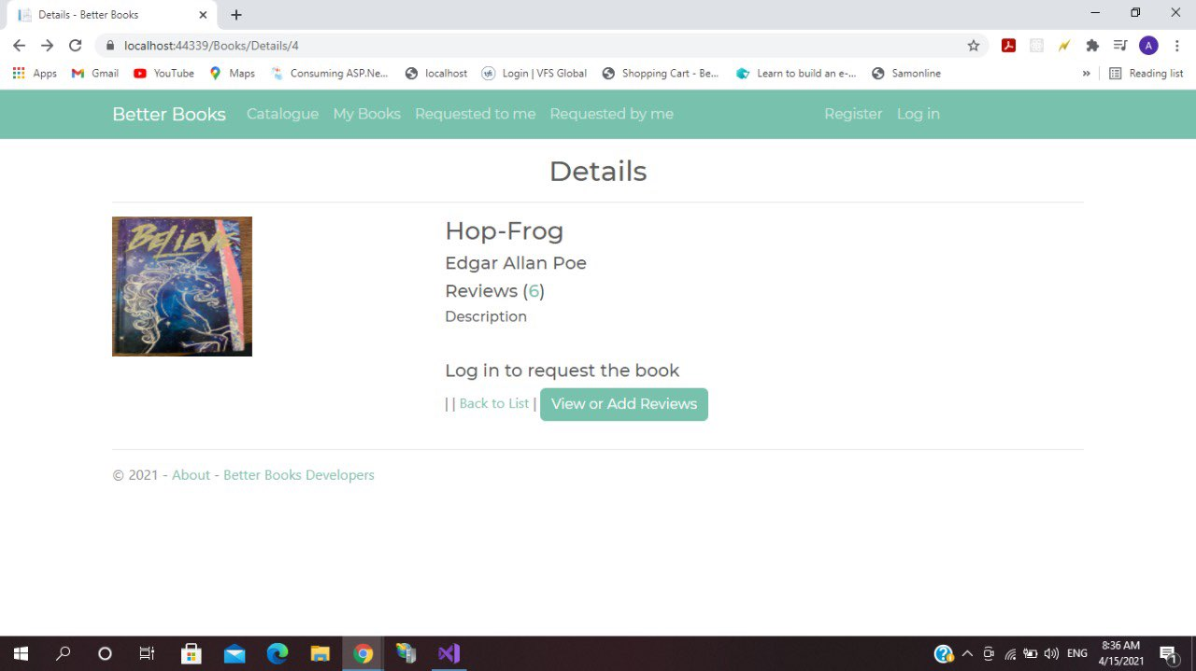

1. Registering an account
2. On the top right hand side of the main catalogue in the banner section, you should see two links that say “Register” and “Log in”, Please select the register, this will redirect the user to a registration page to be able to sign up and use our full services. The user only needs to enter an email account, password, and a confirmation of that password to sign up for our services.

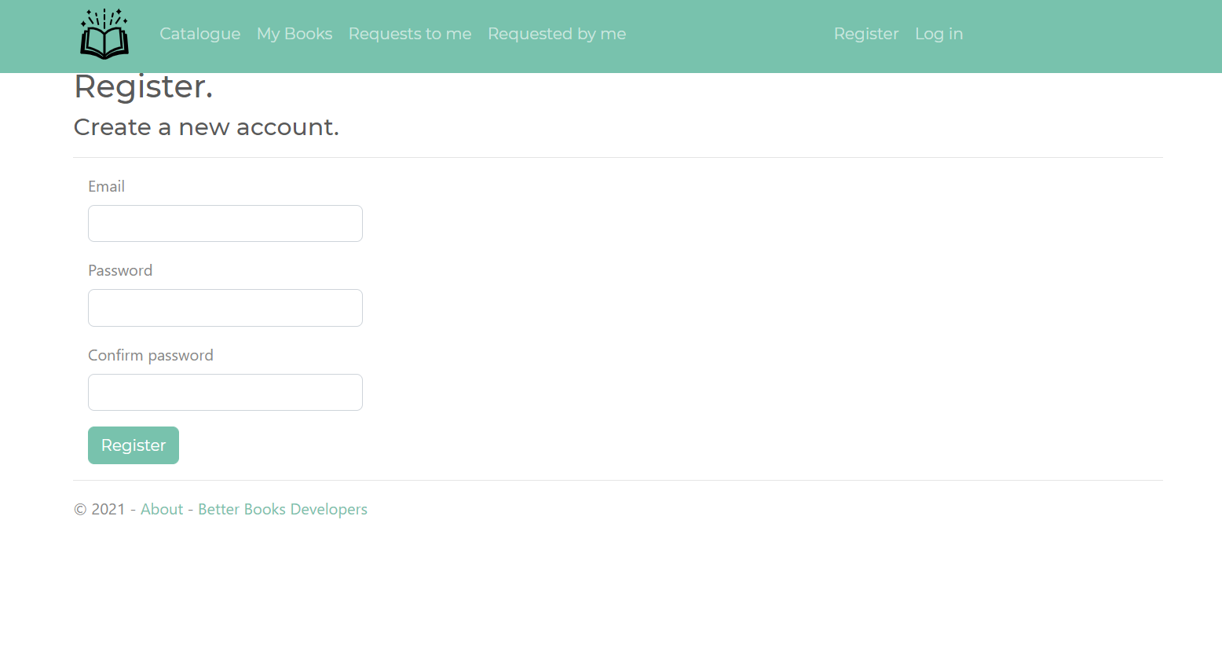

1. If the user already has an account with our product, they should go into the “log in” tab mentioned in the previous step. Once in the log in page, the user has to enter their email and password that they used to create the account and log in from here.

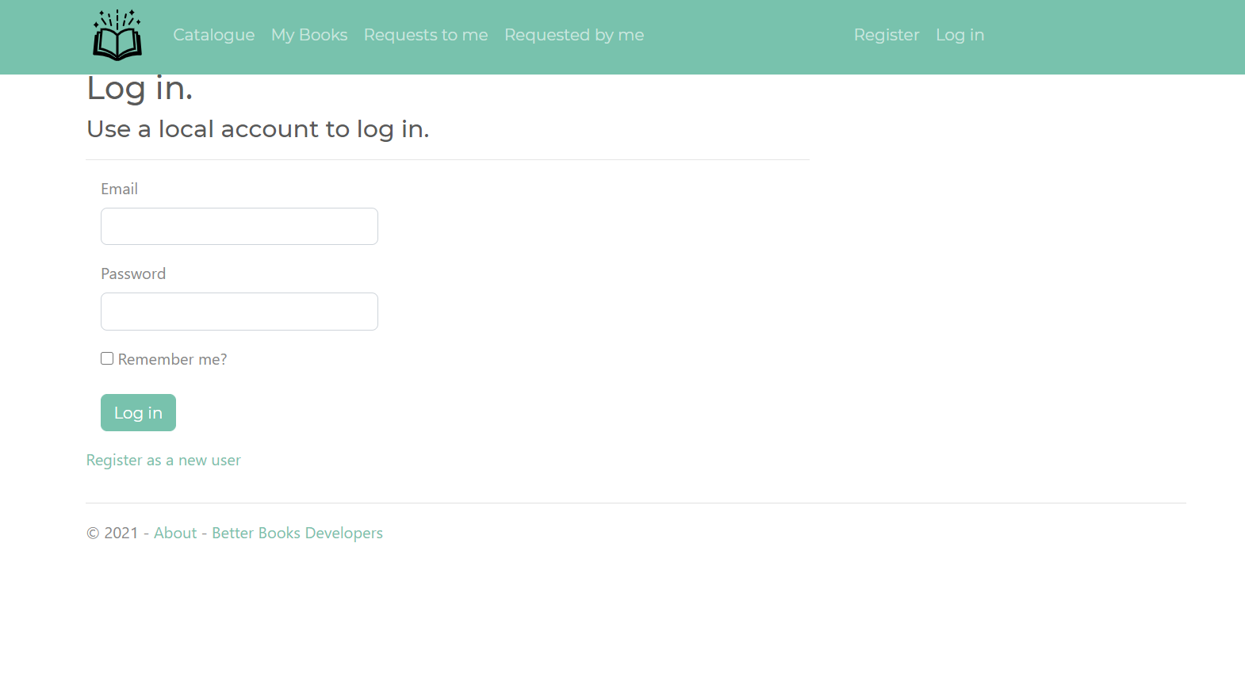Once logged in, the user now has a few more options that are made available to them and we will be reviewing those options one by one. Starting with the top right hand side, the user can go into their account details from the “hello ‘email account’” option, and from there, they are able to change their account password. From there the user has to enter their current password, enter their new password and enter it again in the confirmation text box and confirm their password change.

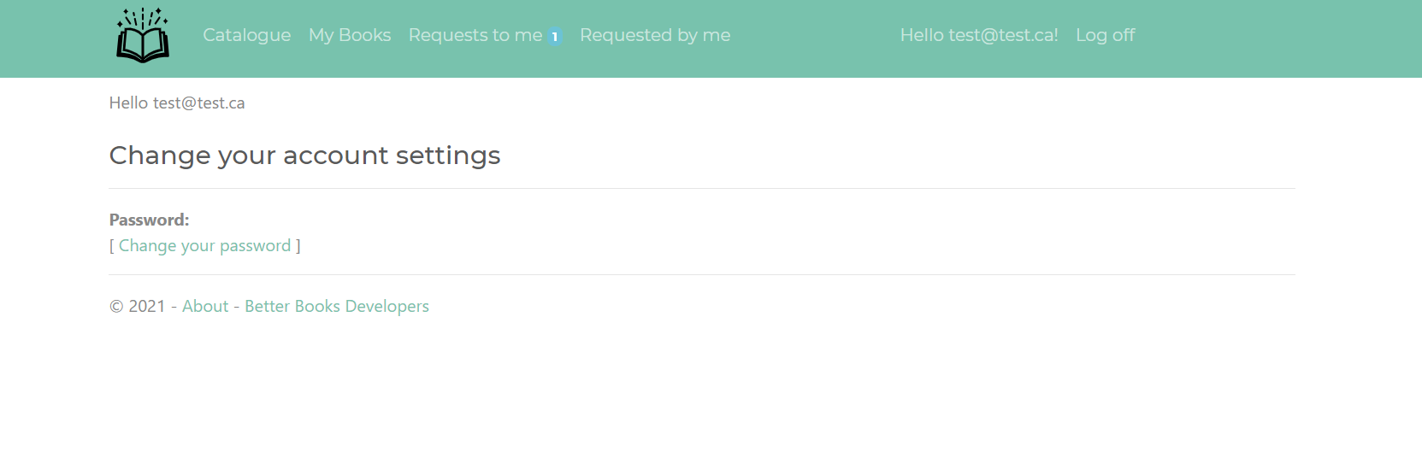

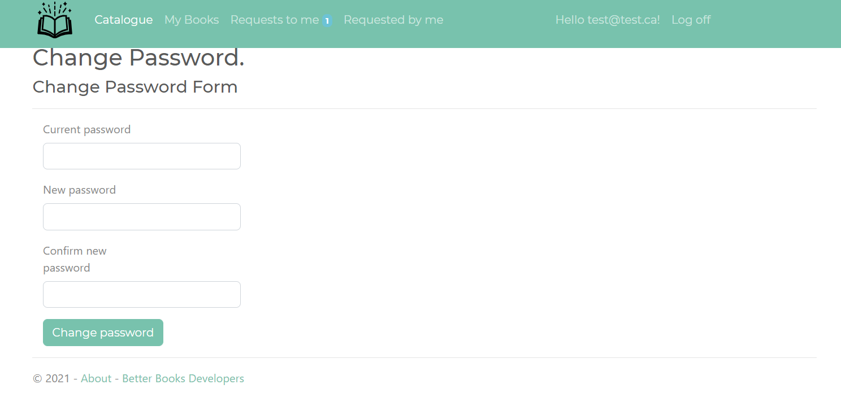

1. Your books
2. On the main catalogue page after logging in the user should be able to see a button to add a new book. From there the user can add their own book to the catalogue, each book requires a title, author, publish date, and cover image. Once all the details are added, the user has to press the save button below to add the book.

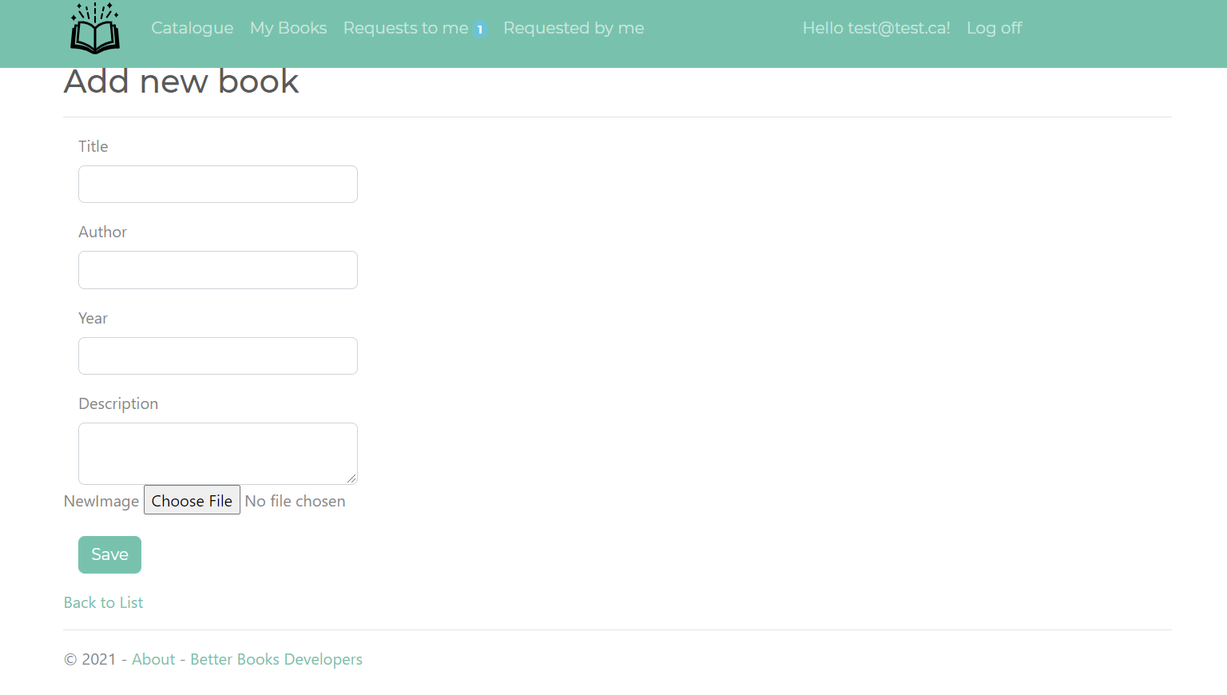

1. Once the user has created a book, it will now be viewable in the main catalogue for requisition. Another to view your added title is to select the “My Books” tab listed in the top banner, from there we can edit or delete our title. If the user wishes to change any of the information for their titles, they can select the edit tab and that will allow them to change any of the book information they wish to adjust and save their changes.

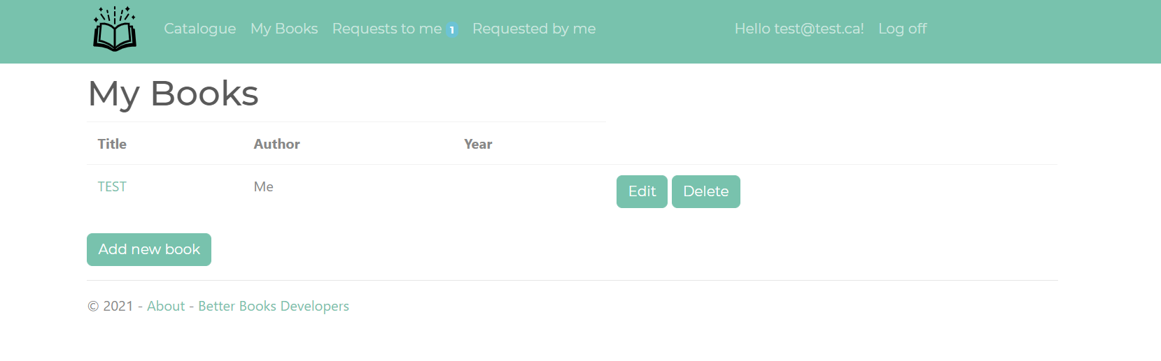

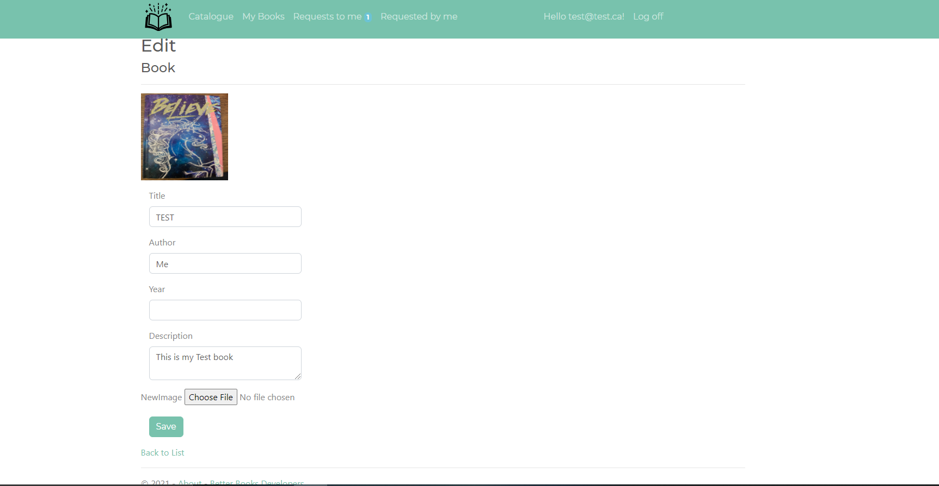

1. From the same my books page, the user is also able to select the option to delete their book from the catalogue. Once selected it will take them to a confirmation page for the user to decide whether they wish to delete their book permanently or not, once they select the delete button, the book will be removed from the catalogue.

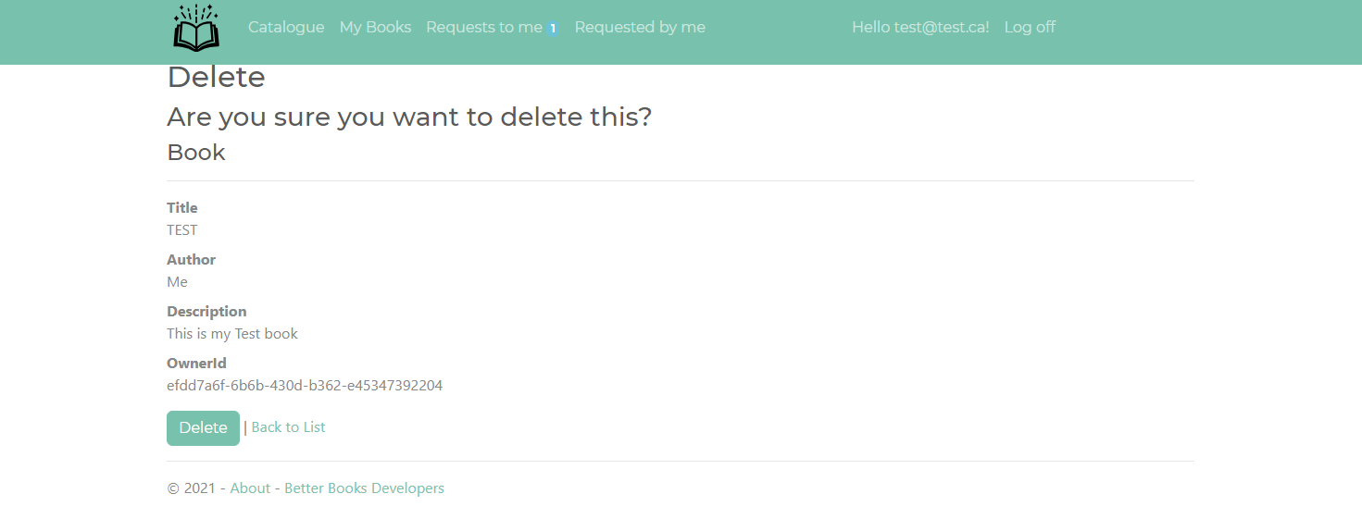

1. Requesting
2. After logging in the user has the ability to access our requesting system, from here they are able to send and receive book requests. A user can request any book that doesn’t belong to them by simply selecting the request it option from either the catalogue or through the book details page. Once requested the button will change in a cancel request button.

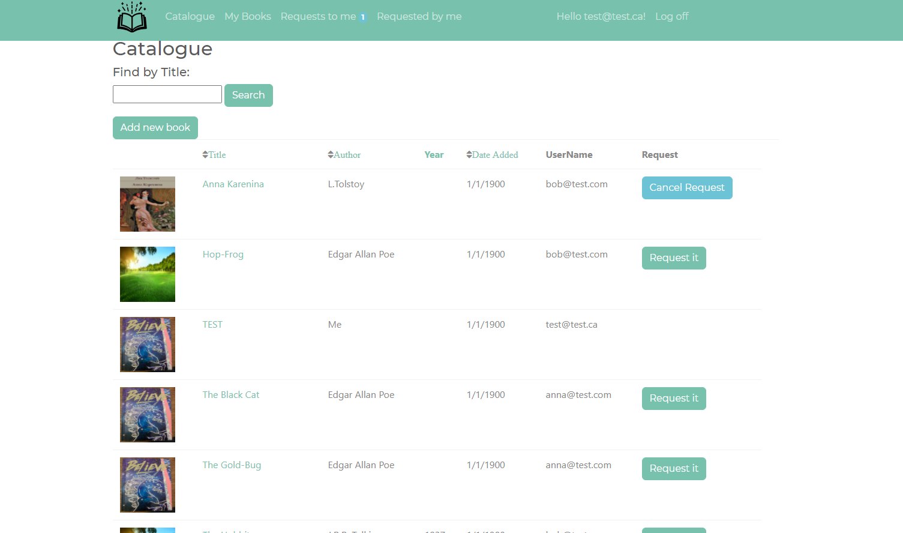

1. Users can also receive requests for books they have added to the catalogue they will see numbered badge icon next the “Requests to me” tab in the banner. From there they are able to view their request from the other user and decide whether they accept or reject the request. If they choose to accept they have the option to reject it at any point in time afterwards. They can also view their contact information from the user email button.

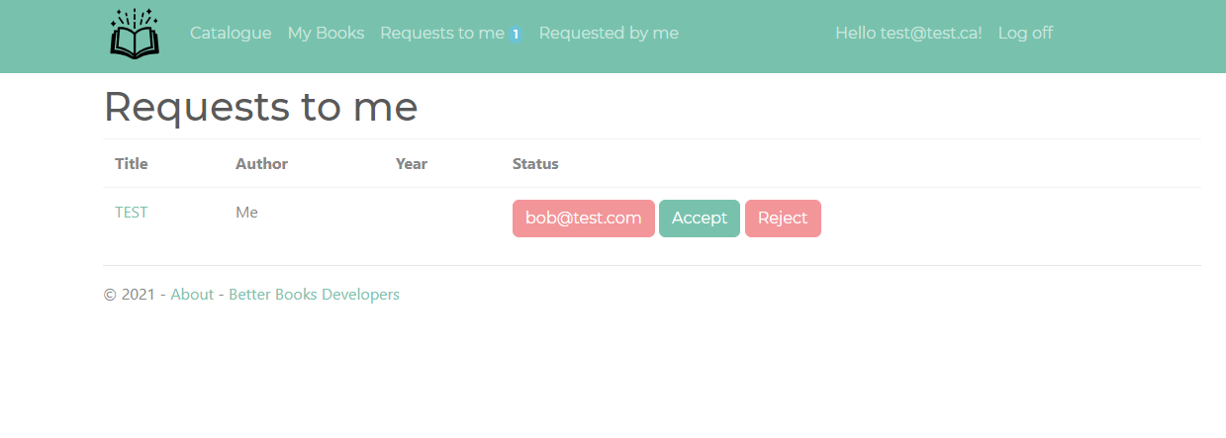

1. Under the “Requests by me” tab in the banner, users can check their requests to see if they have been accepted or rejected and even cancel their request from there if they decide they don’t want that specific title anymore. If the request is accepted by the owner, the user can view their contact information under this tab to be able to contact the owner.

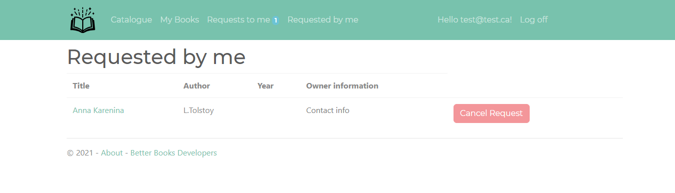

1. Reviews.

Anyone has the ability to add reviews to any book they choose, under the details tab of each book there’s a button to lead them to the reviews page where they can add a little description of what they thought of the book and give it a rating from 1 to 5 stars.

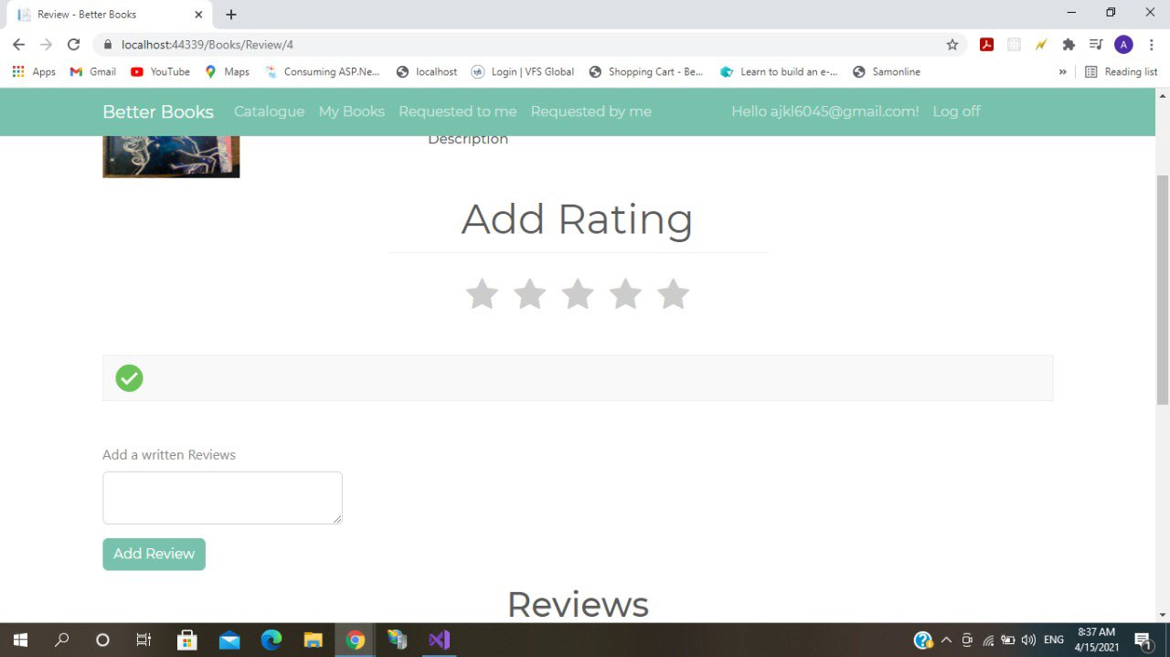

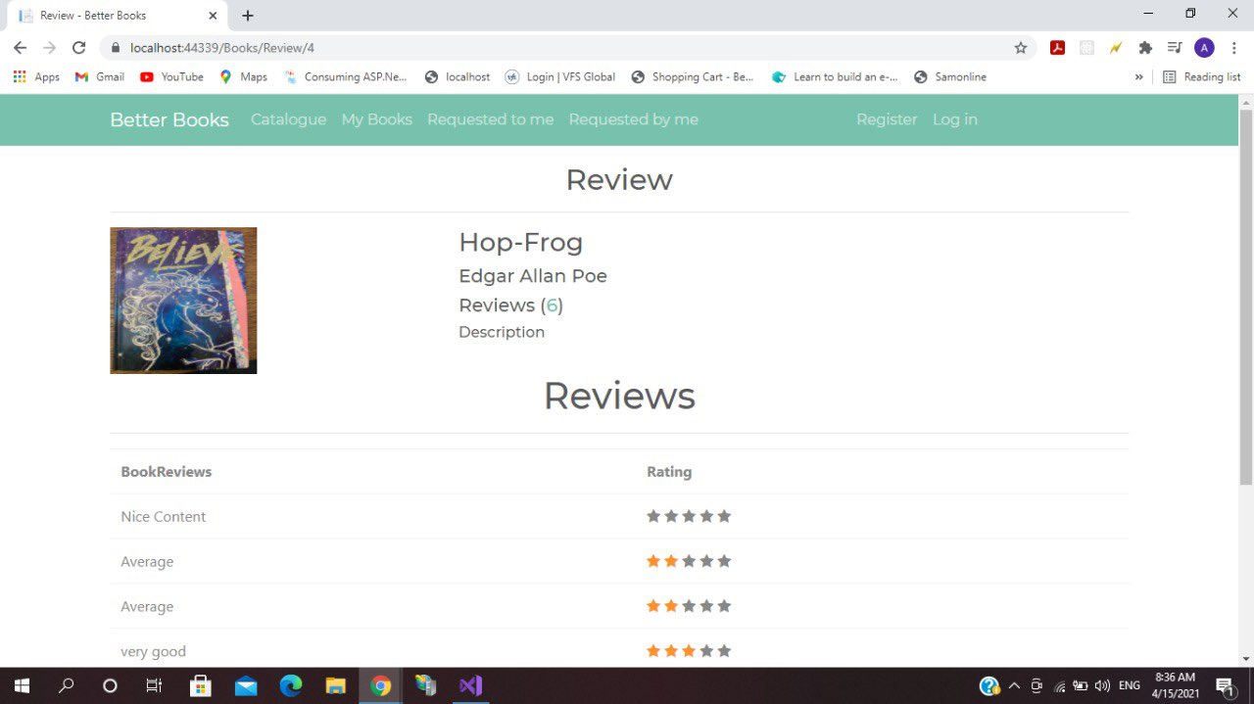

**Conclusion**

That is the Better books website, there are still a few bugs and future features that will be added on at a later date but is currently what is active and published at the moment. We hope to expand our resources and eventually create a fully self-sustaining book lending website that is run by the users for the users.